Colorado Asphalt Pavement Association
Technical Resources Library
Roadway Smoothness
Using Apps to help with Roadway Smoothness. This is a report from the University of Michigan which studied 3 different roadway smoothness apps
"Smoothness Matters, Smooth Pavements Save Fuel and Even Small Changes Can Make a Big Difference" From AsphaltRoads.org
Information was presented at the November 5, 2004 All Industry Open Meeting about roadway smoothness and the use of IRI data. Use the link provided to access the presentation presented by RoadTrac, Inc.
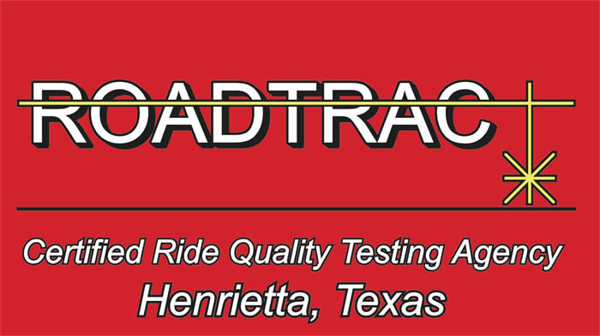
http://www.smoothpavements.com/
The above link will show you the specification for all states where HSP is being used.

