Colorado Asphalt Pavement Association
Technical Resources Library
Roadway Noise
"Smoothness Matters, Smooth Pavements Save Fuel and Even Small Changes Can Make a Big Difference" From AsphaltRoads.org
PAVEMENT NOISE
New APA Web site quietpavement.com Highlights Pavement Noise-Reducing Benefits of HMA
The Asphalt Pavement Alliance has launched a new educational Web site for the public and paving industry highlighting the pavement noise-reducing benefits of HMA. quietpavement.com is an interactive learning experience about the impact of road noise in our lives as well as methods for reducing road noise using hot mix asphalt.
Visit SoundTown USA at the site to build your own neighborhood and discover how you can reduce road noise inside your home. In How loud is loud?, learn what a blender, a barking dog and a vacuum cleaner can teach us about road noise (and the decibel system), as well as how the ear works in Come Hear!
Finally, discover how Julius Caesar stopped traffic noise at its source back in 44 BC in the History of Road Noise. Ever since the first road was built there has been road noise ... learn how modern hot mix asphalt pavements help reduce it. All this information and more is just one click away at quietpavement.com!
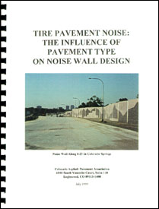 | Considering a "noise all" for your project? CAPA has developed this study which addresses the growing concern of pavement/tire noise problems. Studies nationally and internationally have indicated that noise levels from asphalt pavements are much less than those from concrete pavements.  In addition, roadside noise barriers are not only expensive, but are not a complete solution to the nearby residents as well as the vehicle occupants.  To receive a complimentary copy, give us a call at (303) 741-6150 or e-mail office@co-asphalt.com

