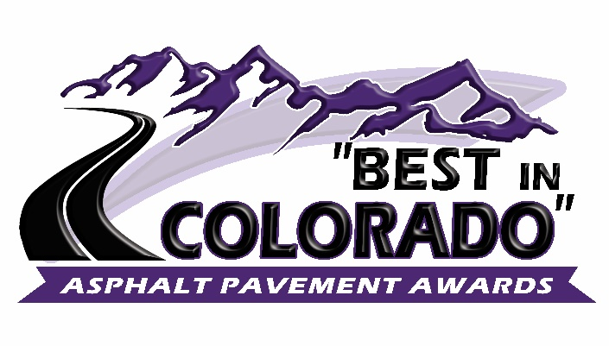

27th Annual

Do you have an exceptional asphalt pavement project that was constructed in 2020? If so, why not submit it for consideration in CAPA’s 27th Annual “Best in Colorado” Asphalt Pavement Awards Program? Award categories include:

City Street Project Innovation
Surface Treatment Residential Subdivision
Project Delivery In-Place Recycling Treatments
Urban Highway Rural Highway Commercial Parking Lot Small Contractor Paving Airport Golden Oldie
Special Use Pavement

The “Best in Colorado” asphalt pavement awards program is open to all asphalt users, producers and contractors. Projects nominated for awards can be submitted by the owner/agency and/or the contractor. Nomination forms are available for download on the CAPA website and must be submitted by October 30, 2020.

A panel of judges from Local Agencies and organizations such as APWA, CARSE, ACEC, CDOT, FHWA, will review and rate all nominated projects. If you have questions, please contact Mike Skinner at mikeskinner@co-asphalt.com.

